ISP Bridge Board User Manual

The information described in this document is the exclusive intellectual property of
Nuvoton Technology Corporation and shall not be reproduced without permission from Nuvoton.

Nuvoton is providing this document only for reference purposes of NuMicro™ microcontroller based system design. Nuvoton assumes no responsibility for errors or omissions.
All data and specifications are subject to change without notice.

For additional information or questions, please contact: Nuvoton Technology Corporation.

1 Overview 3
2 ISP Bridge Board Introduction 3
2.1 Functional Block of ISP Bridge Board 4
2.2 Power Plan 6
2.3 Programmer Connector 7
3 Schematic 8
3.1 LED 8
3.2 Buzzer 8
3.3 Button 9
3.4 320x240 TFT LCD 9
3.5 CAN and RS485 Transceiver 10
3.6 SPI Flash 10
3.7 SD Card Slot 11
3.8 External Programmer Connection 12
3.9 LDO (5V to 3V) 12
3.10 Main Chip(NUC240VE3AN) 13
4 Revision History 14

Overview

ISP is the acronym of In-System Programming, which makes it possible that the user can update the program
memory under the software control without removing the mounted MCU chip from the actual end product. As long as the LDROM of the MCU is pre-programmed with the Nuvoton Standard ISP Code and CONFIG bits are properly configured, the user can easily update the APROM of the MCU through the COM/USB port of PC. But I2C/SPI/RS485/CAN interface cannot direct connect with PC, we provide an ISP bridge board solution through the USB port of PC. The ISP Bridge board is ISP programmer bridge tool for NuMicro series. It have support on-line (I2C/SPI/RS485/CAN) and off-line (I2C/SPI/RS485/UART/CAN) ISP programming.

ISP Bridge Board Introduction

The ISP Bridge Board uses the NUC240VE3AE as the target microcontroller and includes rich functional blocks on board. Figure 2-1 is the show ISP Bridge Board. The positive ISP Bridge Board includes main chip (NUC240VE3AE), 4 input key, reset key, 4 LEDs, 320x240 TFT LCD, SD Card slot, Buzzer, USB connector, the negative have SPI flash, CAN transceiver, RS485 transceiver.

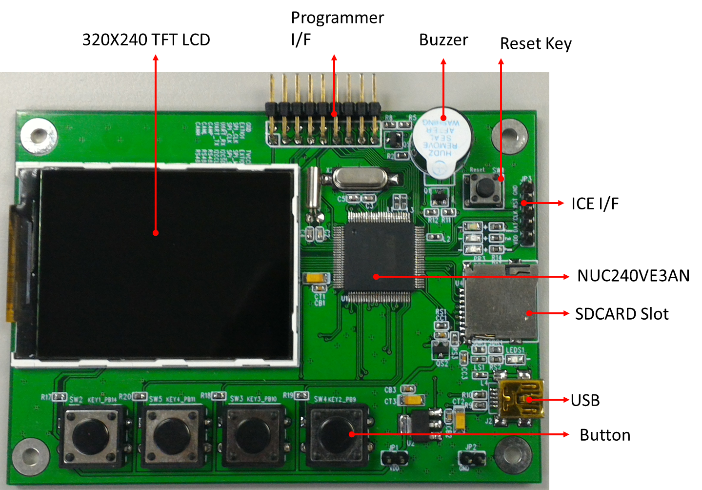

Figure 2-1 ISP Bridge Board

Functional Block of ISP Bridge Board
ISP Bridge Board provides the rich functional blocks connected with NUC240VE3AE to display information, communicate with PC, store data and interact with human. Users can follow the pin assignment at Table 2-1 to control every functional block.

Functional Block | Pin assignment | Pin Function Description
ICE connect | ICE_CLK  ICE_DATA | SWD interface
Reset Key | /RST | Reset
Button | PB.14  PB.9  PB.10  PB.11 | GPIO(input)  GPIO(input)  GPIO(input)  GPIO(input)
Buzzer | PB.8 | GPIO
LEDs | PA.12  PA.13 | GPIO(RED LED)  GPIO(GREEN LED)
Power | PC.14  PC.15 | ACMP CPP  ACMP CPN
Power | PA.4 | GPIO(power control)
Power | PA.0 | ADC(power measure)
CAN | PC.4  PC.5  PD.7  PD.6 | GPIO  GPIO  CAN TX  CAN RX
UART/RS485 | PB.2  PB.1  PB.0 | GPIO (RS485 TX/RX S/W)  UART/RS485 TX  UART/RS485 RX
SPI FLASH | PC.0  PC.1  PC.2  PC.3 | SPISS0  SPICLK0  MISO_0  MOSI_0
SPI | PD.0  PD.1  PD.2  PD.3 | SPISS2  SPICLK2  MISO_2  MOSI_2
SDCARD | PC.8  PC.9  PC.10  PC.11  PC.12  PC.13 | SPISS1  SPICLK1  MISO_1  MOSI_1  GPIO(SDCARD power)  GPIO(SDCARD detect)
320 x240 TFT LCD | PD.8  PD.9  PD.10  PD.11  PD.12  PD.13  PB.4 | SPISS0  SPICLK0  MISO_0  MOSI_0  GPIO (LCD D/C)  GPIO (LCD RESET)  GPIO (LCD POWER)
Test | PE.7  PE.8  PA.10  PA.11  PB.7  PB.6  PD.4  PD.5  PC.7  PC.6  PC.14  PB.13 | GPIO (T1)  GPIO (T2)  GPIO (T3)  GPIO (T4)  GPIO (T5)  GPIO (T6)  GPIO (T5)  GPIO (T6)  GPIO (T7)  GPIO (T8)  GPIO (T9)  GPIO (T10)
Table 2-1 Functional Block for ISP Bridge Board

Power Plan
The ISP Bridge Board need external 5V power on USB port(J2), the system voltage is 3.3V, the external voltage the MCU can control, all system current is 270mA(without target chip)
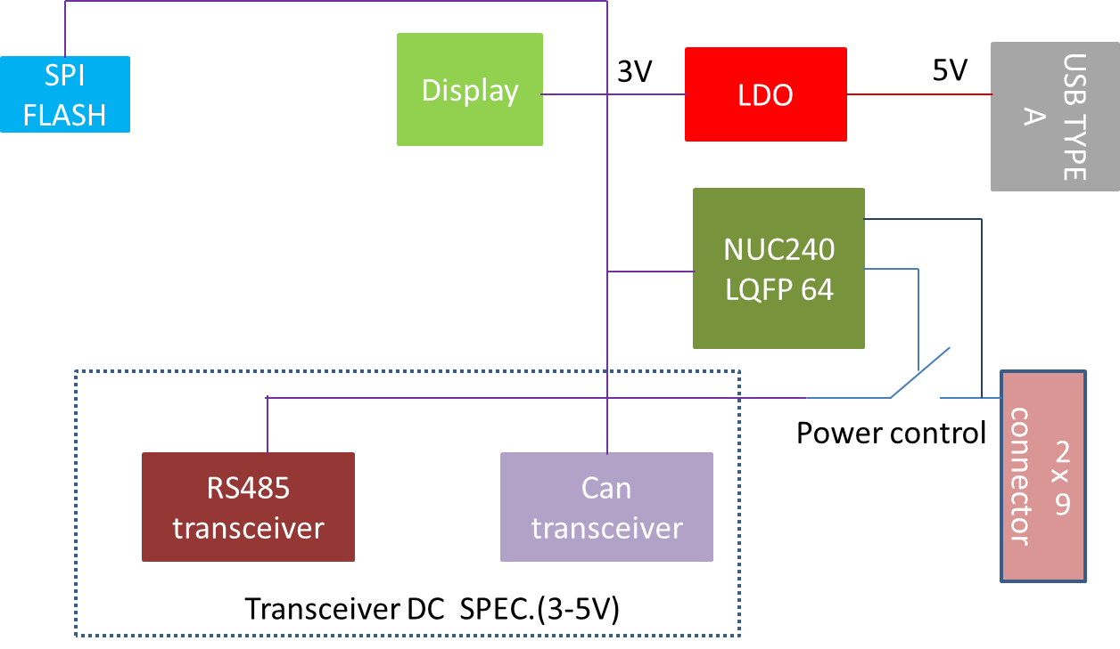
Figure 2-2 ISP Bridge Board Power Plan

Programmer Connector
The ISP Bridge board have provider external programmer connect, it have support RS485, UART, CAN,I2C, SPI interface with 2 external I/O
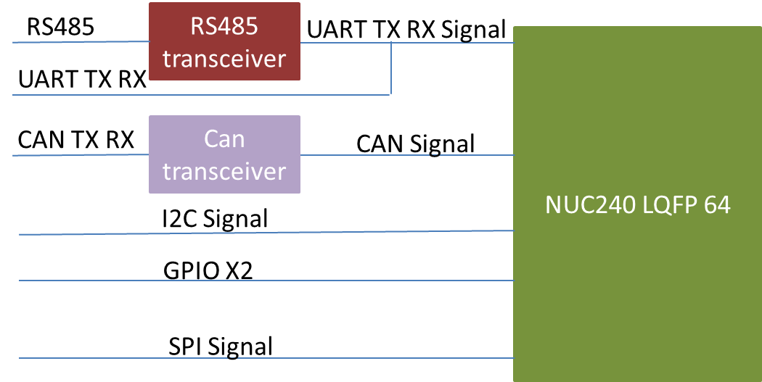
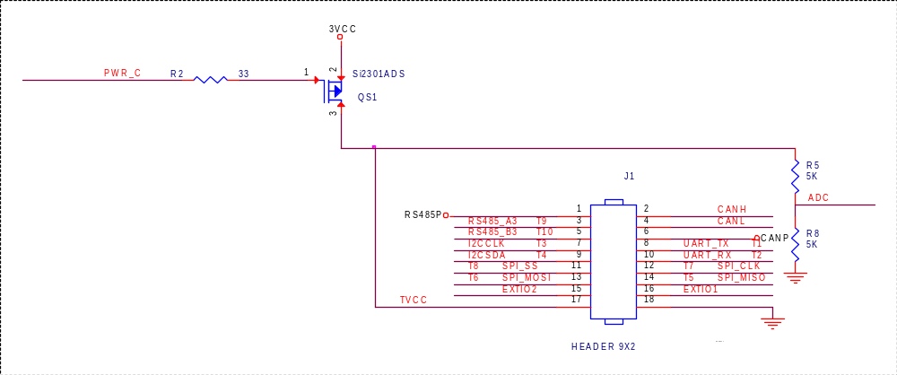
Figure 2-3 ISP Bridge Board Programmer Connector

Schematic

LED
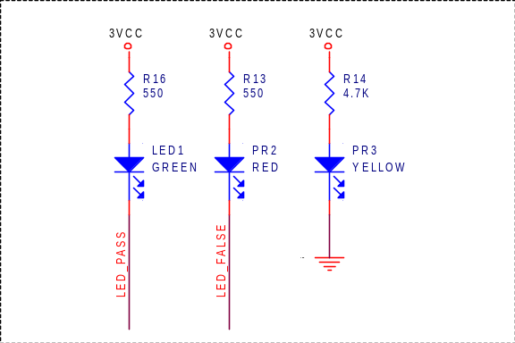

Buzzer
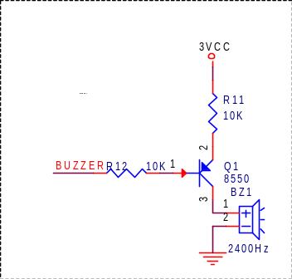

Button
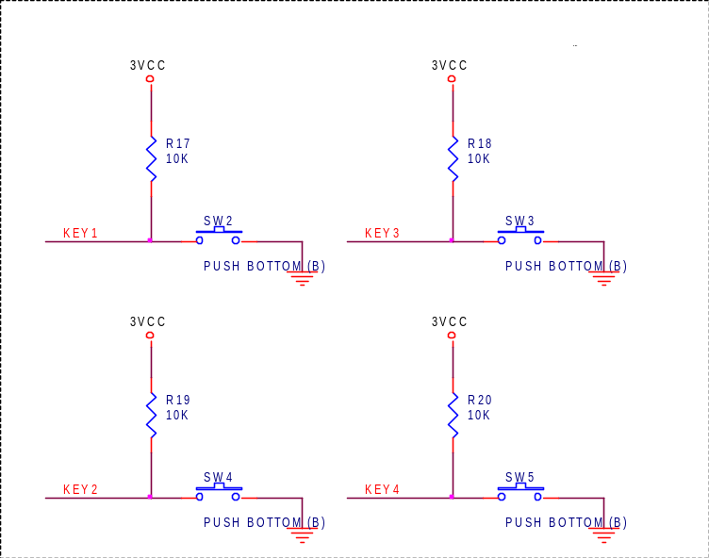

320x240 TFT LCD
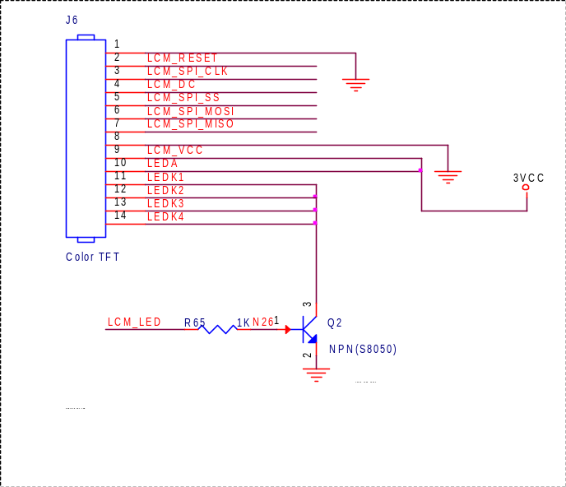

CAN and RS485 Transceiver
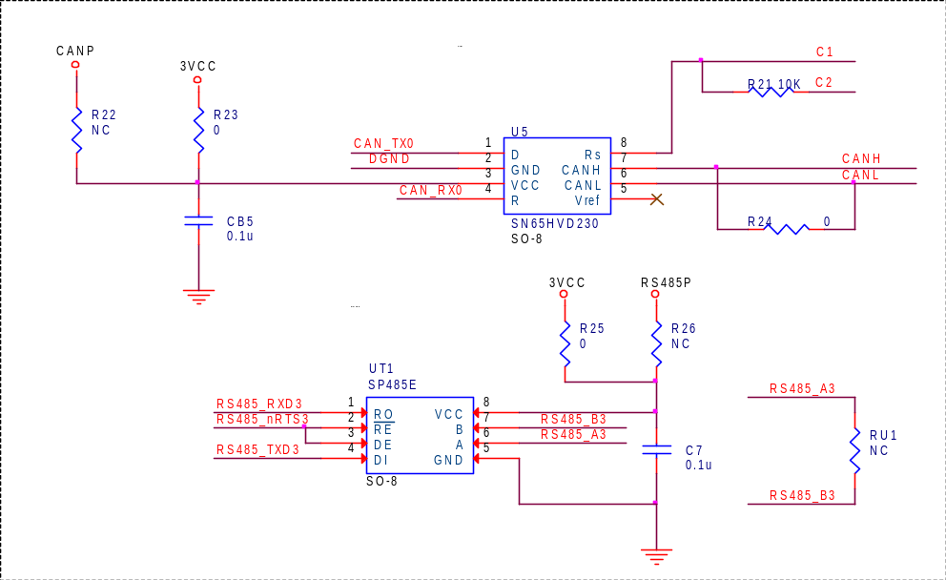

SPI Flash
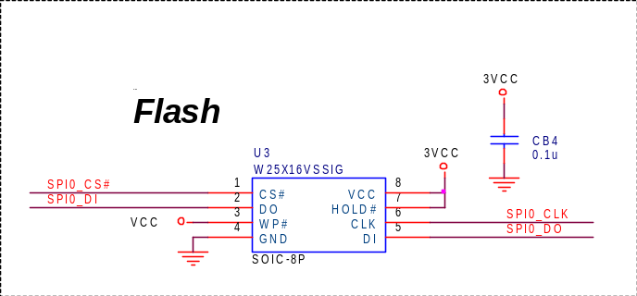

SD Card Slot
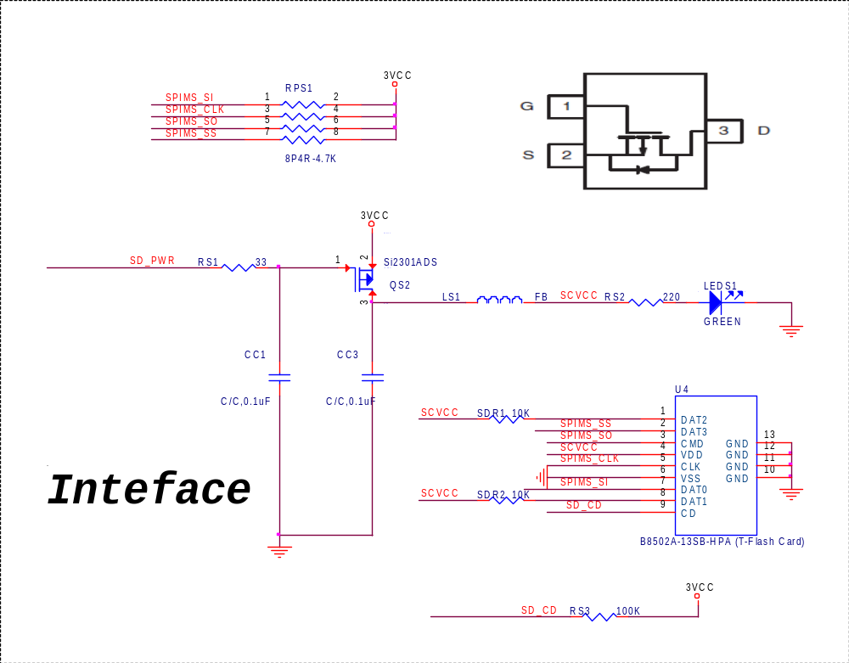

External Programmer Connection
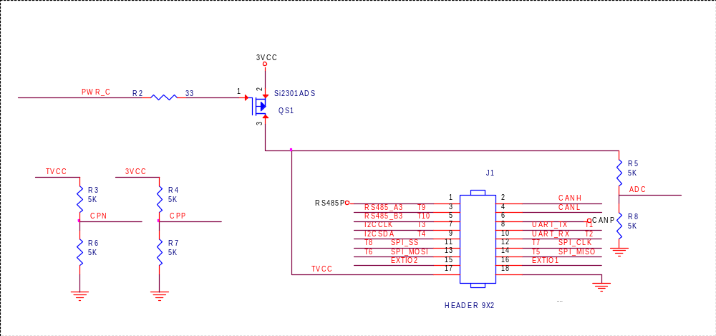

LDO (5V to 3V)
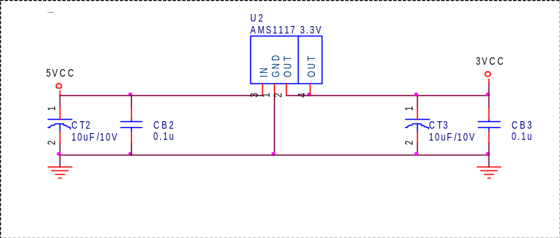

Main Chip(NUC240VE3AN)
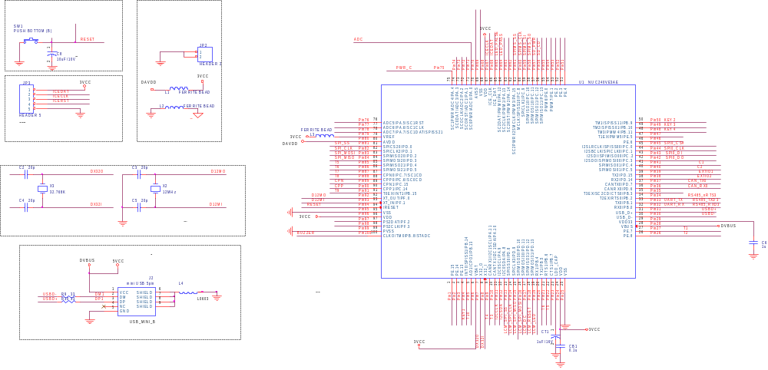

Revision History

Version | Date | Page | Description
1.0 | July. 14, 2016 | -- | Initial Release

Important Notice
Nuvoton products are not designed, intended, authorized or warranted for use as components in systems or equipment intended for surgical implantation, atomic energy control instruments, airplane or spaceship instruments, transportation instruments, traffic signal instruments, combustion control instruments, or for other applications intended to support or sustain life. Further more, Nuvoton products are not intended for applications wherein failure of Nuvoton products could result or lead to a situation wherein personal injury, death or severe property or environmental damage could occur.
Nuvoton customers using or selling these products for use in such applications do so at their own risk and agree to fully indemnify Nuvoton for any damages resulting from such improper use or sales.

Please note that all data and specifications are subject to change without notice. All the trademarks of products and companies mentioned in this datasheet belong to their respective owners.

